***Frontend Development with React.js***

***Project Documentation for cook book***

1. **Introduction** 
   * **Project Title**: **Cook book**
   * **Team Members**:

**Chandru S** (**Team Leader**) [Email Id: mschandrau@gmail.com]

**Harisiva L** [Email Id: lharisiva1010@gmail.com]

**Lakshmikanthan M**  [Email Id: lakshmikanthanm275@gmail.com]

**Kishon raj L**  [Email Id: kishonraj087@gmail.com]



1. **Project Overview**

**Purpose**

**The Recipe Application serves as a comprehensive platform for food enthusiasts to:**

* **Discover new recipes across various categories**
* **Search for specific recipes**
* **Save favorite recipes**
* **Access detailed cooking instructions**
* **Share recipes with others**

**Key Features:**

* **Recipe categorization and browsing**
* **Advanced search functionality**
* **User authentication and profiles**
* **Favorite recipe management**
* **Responsive design with 3D animations**
* **Dark/Light theme support**
* **Category-based recipe filtering**
* **Recipe detail views with ingredients and instructions**
* **Loading states and error handling**
* **Smooth scrolling and animatio**

1. **Architecture**

**Technology Stack**

**- Frontend: React.js**

**- Routing: React Router v6**

**- State Management: React Hooks + Context API**

**- API Integration: Axios**

**- Styling: CSS Modules + Custom Animations**

**- Authentication: JWT**

**- API: TheMealDB + Spoonacular**

**Routing Structure**

**javascript**

**Routes:**

**- / (Home)**

**- /categories (Categories Overview)**

**- /category/:id (Category Detail)**

**- /recipe/:id (Recipe Detail)**

**- /search (Search Results)**

**- /profile (User Profile)**

**- /saved (Saved Recipes)**

**- /settings (User Settings)**

1. **Setup Instructions**

**Prerequisites**

**- Node.js (v14 or higher)**

**- npm or yarn**

**- Git**

**Installation**

**bash**

**# Clone the repository**

**git clone [repository-url]**

**# Navigate to project directory**

**cd recipe-app**

**# Install dependencies**

**npm install**

**# Create environment file**

**cp .env.example .env**

**# Add your API keys**

**REACT_APP_SPOONACULAR_API_KEY=your_api_key**

1. **Folder Structure**

**recipe-app/**

**├── public/**

**├── src/**

**│ ├── components/**

**│ │ ├── CategoriesHome/**

**│ │ ├── Navbar/**

**│ │ ├── RecipeCard/**

**│ │ └── ...**

**│ ├── hooks/**

**│ │ ├── useScrollAnimation.js**

**│ │ └── ...**

**│ ├── services/**

**│ │ ├── api.js**

**│ │ └── recipeApi.js**

**│ ├── context**/

**│ ├── styles/**

**│ ├── utils/**

**│ └── pages/**

**├── tests/**

**└── docs/**

1. **Running the Application**

**Development Mode**

**bash**

**# Start development server**

**npm start**

**# Access the application**

**Open http://localhost:3000**

**### Production Build**

**bash**

**# Create production build**

**npm run build**

**# Serve production build**

**npm run serve**

1. **State Management**

**Global State**

**- User authentication state**

**- Theme preferences**

**- Saved recipes**

**- Search history**

**### Local State Management**

**- Component-specific states using useState**

**- Custom hooks for reusable state logic**

**- Context API for theme and auth management**

1. **Component Documentation**

**### CategoriesHome Component**

**javascript**

**/\*\***

**\* Displays a grid of recipe categories with 3D animations**

**\* Props: None**

**\* State:**

**\* - categories: Array of category objects**

**\* - loading: Boolean loading state**

**\* - error: Error state object**

**\*/**

**### RecipeCard Component**

**javascript**

**/\*\***

**\* Displays individual recipe information**

**\* Props:**

**\* - recipe: Recipe object**

**\* - onSave: Function to handle saving**

**\* - isSaved: Boolean saved state**

**\*/**

**9. User Interface**

**### Design Principles**

**- Modern and clean interface**

**- Responsive design for all devices**

**- Intuitive navigation**

**- Smooth animations and transitions**

**- Accessible color schemes**

**- Clear visual hierarchy**

**### Key UI Elements**

**- Navigation bar with search**

**- Category cards with 3D effects**

**- Recipe detail layouts**

**- Loading states and error messages**

**- User profile interface**

**- Settings panel**

**10. Styling**

**### CSS Architecture**

**- CSS Modules for component isolation**

**- Global variables for theming**

**- Responsive breakpoints**

**- Animation utilities**

**- Dark mode support**

**### Animation System**

**css**

**/* Base animations */**

**@keyframes slideInUp {**

**from {**

**transform: translateY(50px) translateZ(-20px);**

**opacity: 0;**

**}**

**to {**

**transform: translateY(0) translateZ(0);**

**opacity: 1;**

**}**

**}**

**11. Testing**

**### Test Structure**

**bash**

**tests/**

**├── unit/**

**├── integration/**

**└── e2e/**

**### Running Tests**

**bash**

**# Run all tests**

**npm test**

**# Run specific test suite**

**npm test -- -t "CategoriesHome"**

**# Generate coverage report**

**npm test -- --coverage**

**12. Known Issues**

**### Current Limitations**

**- API rate limiting with Spoonacular**

**- Image loading optimization needed**

**- Mobile performance optimization**

**- Search functionality refinement**

**### Workarounds**

**- MealDB API fallback**

**- Lazy loading for images**

**- Debounced search implementation**

**13. Future Enhancements**

**### Planned Features**

**- Recipe creation and sharing**

**- Social features and comments**

**- Advanced filtering options**

**- Nutrition information**

**- Shopping list generation**

**- Meal planning calendar**

**- Recipe scaling functionality**

**- Print-friendly recipe views**

**### Technical Improvements**

**- PWA implementation**

**- Performance optimization**

**- Offline support**

**- Image optimization**

**- Advanced caching**

**- Analytics integration**

**- Accessibility improvements**

**14.Screenshot & Demo link**

**HOME PAGE**

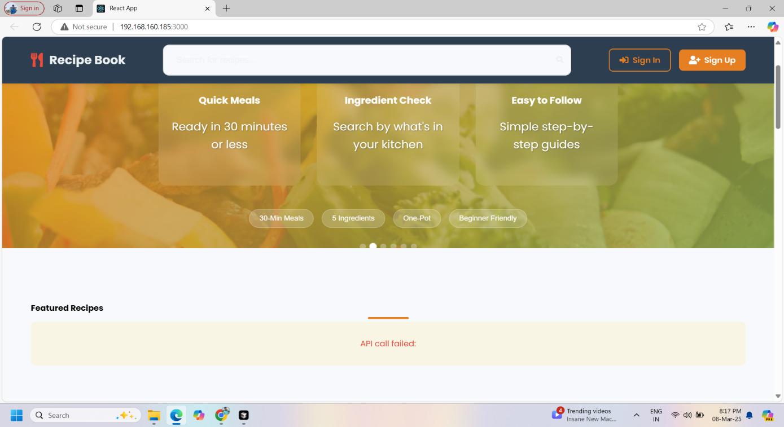

**CATEGORYS PAGE**

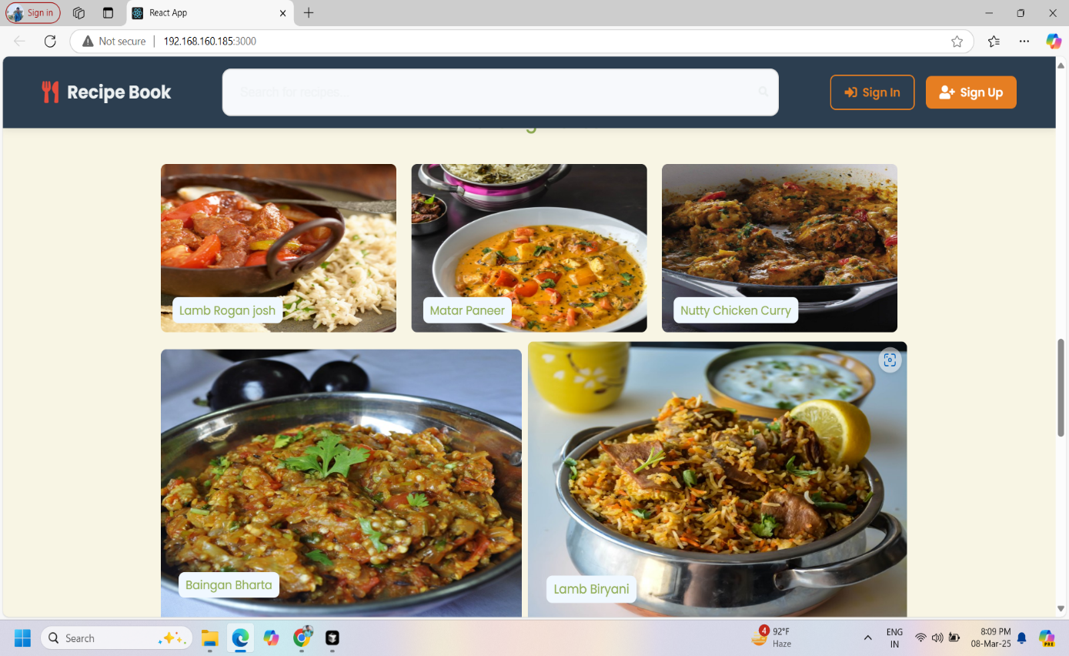

-

**GOOGLE DRIVE LINK** <https://drive.google.com/drive/folders/14iCGhmZtklOL4EU9epygiCW0Jl2CNVwQ?usp=sharing>

**VIDEO LINK:**

<https://drive.google.com/file/d/15-6Rl8nug89PfjavfG6OCkVScjXi2m0j/view?usp=sharing>